Nathan Doan
Professor Kemper
Phys 121L Sec. 4
2 February 2024

Sample Calculations
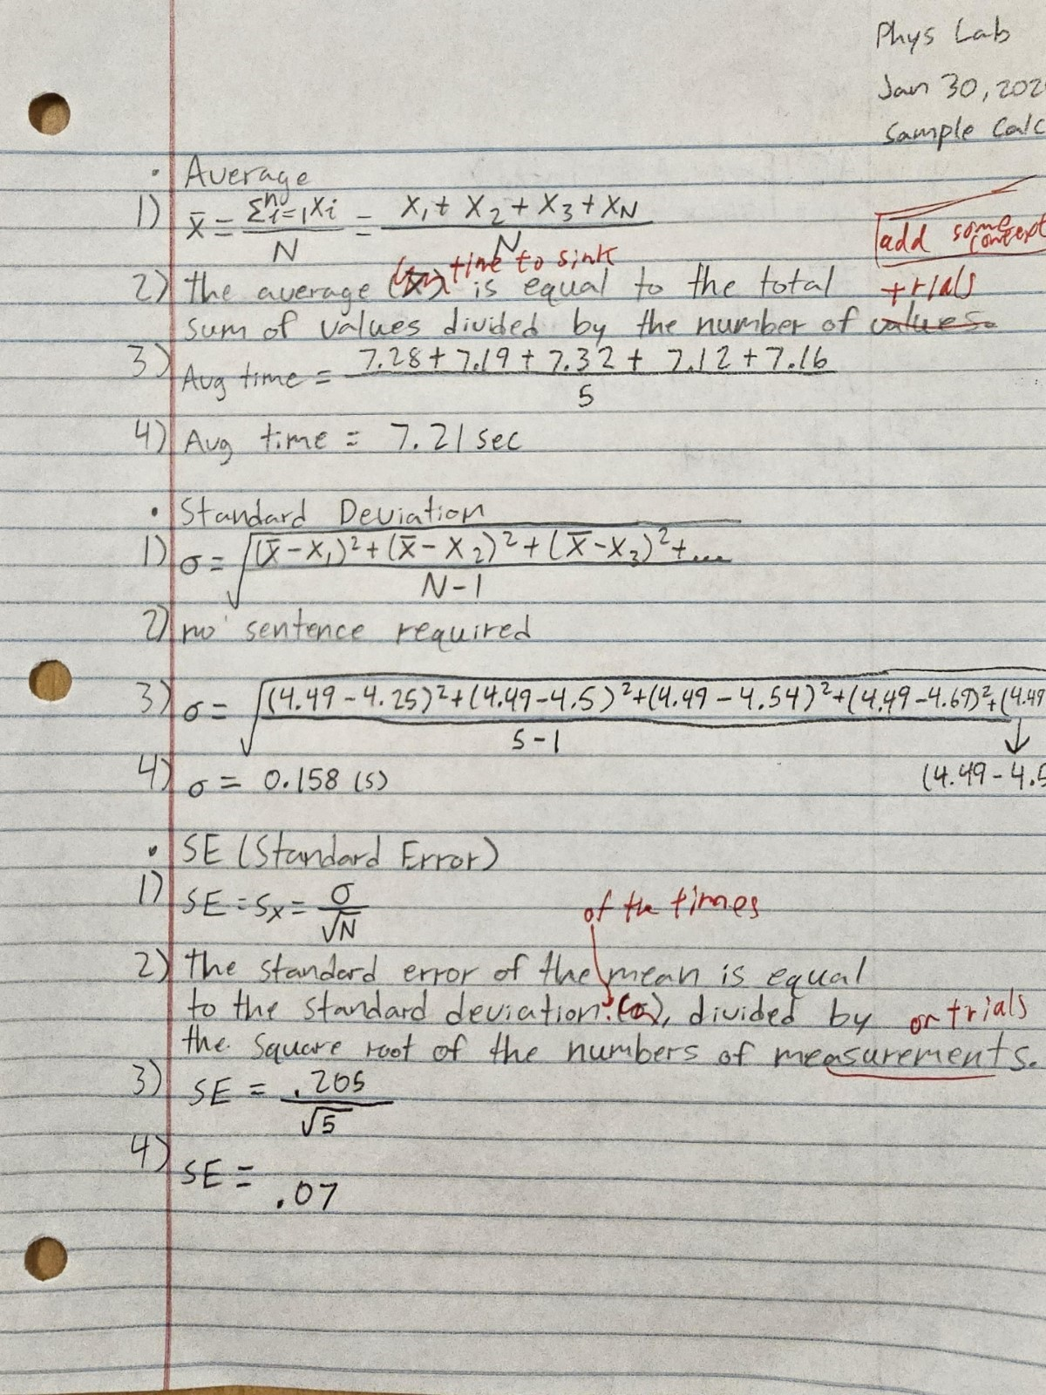
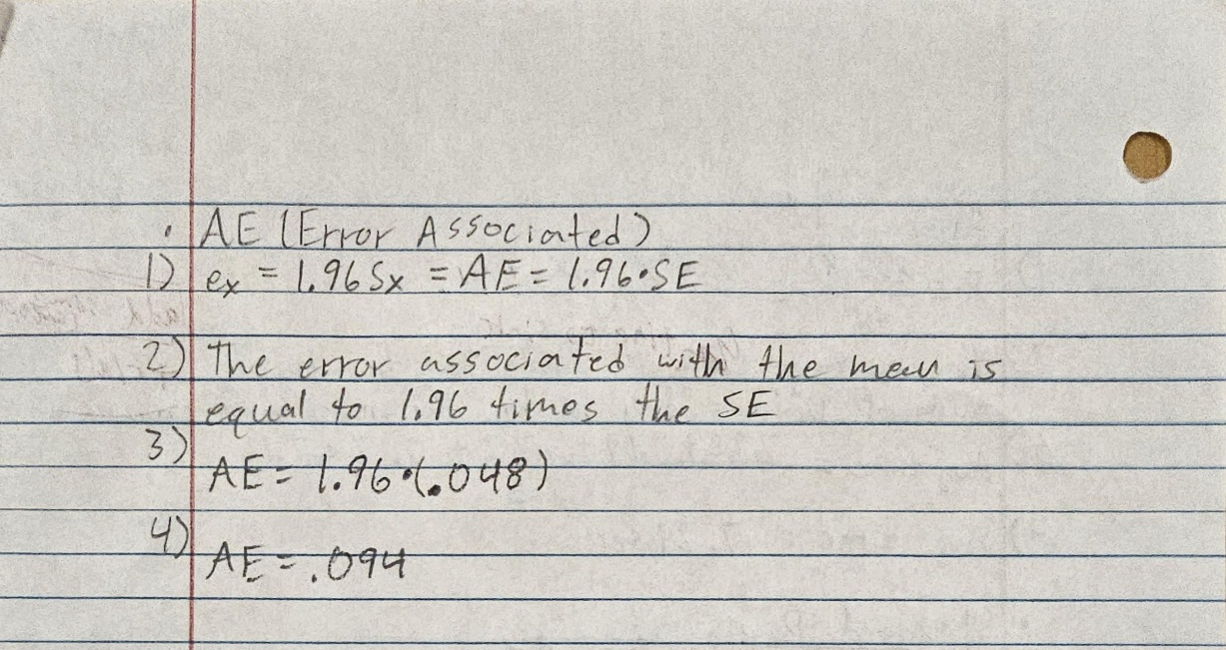

Challenge
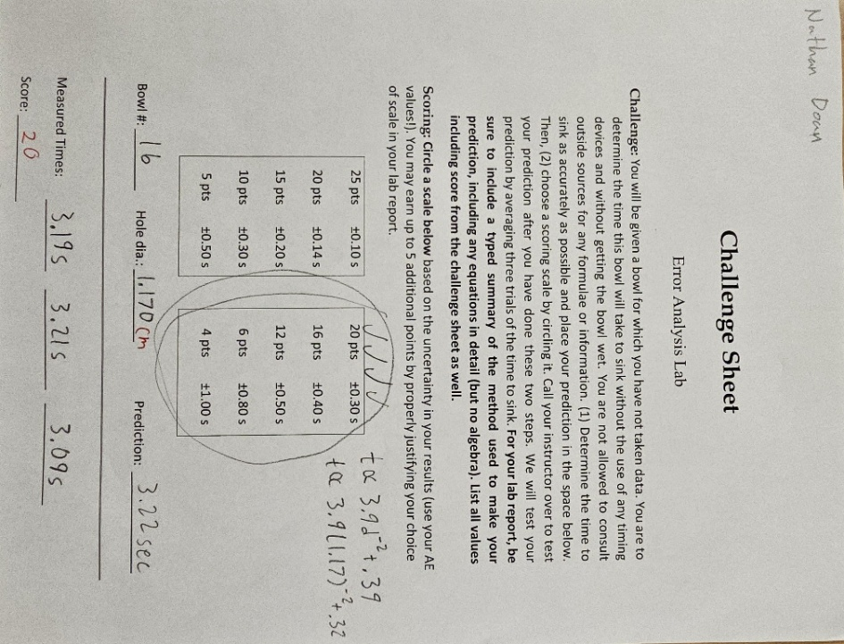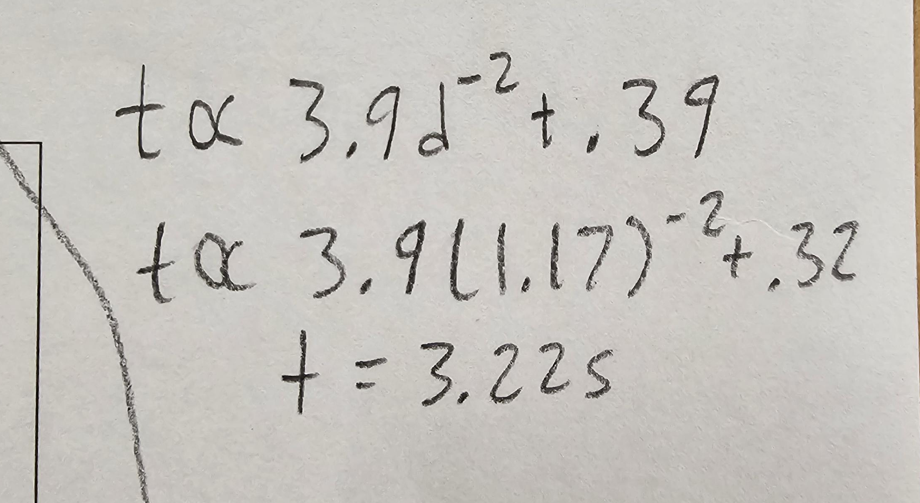
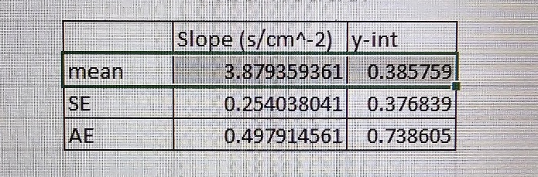

Discussion
1. Two data sets, each with the same number of trials for the same time measurement of a system, produce standard deviations of 0.38 s and 0.89 s. What can you say about the data sets that produced each of these? (5 pts)
- Having a large difference between two sets of standard deviation would indicate some form of error occurring. In our case, regarding the lab, the error would be a random error taken to the extreme. A fault of human reaction time with the stopwatch. Or, it is possible the stopwatch could malfunction as well.
2. Why do we perform multiple timing trials with each bowl in this lab? Explain using the terminology you learned in this lab handout. (3 pts) & Discussion prompt #2: Which source of random error has the largest effect?
- Multiple timing trials are performed to reduce the impact of random errors and to obtain a more accurate and reliable average time measurement. This is based on the law of large numbers which states that as the number of trials increases, the average of the results obtained should get closer to the expected value. We do this because it is assumed the largest source of random error is from human reaction speeds.
3. Which source of random error probably had the largest effect on the final results? (2 pts)
- c. Starting and stopping the stopwatch because it involves human reaction time which can vary significantly
4. Is there a significant source of systematic error in your experiment? Explain how you can tell. (5 pts)
- One potential source of systematic error could be the Vernier caliper. The one we received looked to have a tilted slider, which would make it difficult to correctly read measurements at the hundredths and thousandths-place (as the tick marks on the caliper would be off). These faults can be identified if the results are consistently off by the same amount each time the measurement is taken.
5. What is the minimum reading error of your Vernier caliper? (3 pts)
- The reading error of our Vernier caliper is +/- 0.002cm or +/- 0.02mm.
6. What is the reading error of the stopwatch? (2 pts)
- The reading error of the stopwatch is +/- 0.01 seconds.
7. If you had used the radius instead of the hole diameter in your calculations, how would this have changed the slope of the log-log graph? Explain what method you used to reach your answer, i.e. algebraically, computationally using Excel, etc. (5 pts) When in doubt, just copy your Excel sheet and replace the diameters with the radii to see what happens!
- If we had used the radius instead of the hole diameter in your calculations, it would have halved the values on the x-axis of our log-log graph. This would not change the shape of the graph but would change the slope of the line. We replaced the diameters with the radii in our Excel sheet and observed a change in the slope of the trend line.

